**Project Report Template**

**1** **INTRODUCTION**

1.1 Overview

Project Description

The Project aim is to provide real-time knowledge for all the students who have basic knowledge of Salesforce and looking for a real-time project. This project will also help to those professionals who are in cross-technology and wanted to switch to Salesforce with the help of this project they will gain knowledge and can include into their resume as well.

1.2 Purpose

Event management is the process of creating and maintaining an event. This Process spans from the very beginning of planning all the way to post-event strategizing

At the start, an event manager makes planning decisions, such as the time, location, and theme of their event. During an event, event managers oversee the event live and make sure things run smoothly. After an event, event managers are tasked with reviewing event data, submitting KPI and ROI findings, and staying on the ball for any post-event offerings.

All different branches of planning go into event management, including various types of sourcing, designing, regulation checks, and on-site management. In event management, you could be in the process of creating a conference, a product launch, an internal sales kick-off, or even a wedding. Really, any event that requires considerable planning and execution is event management.

**2** **Problem Definition & Design Thinking**

2.1 Empathy Map

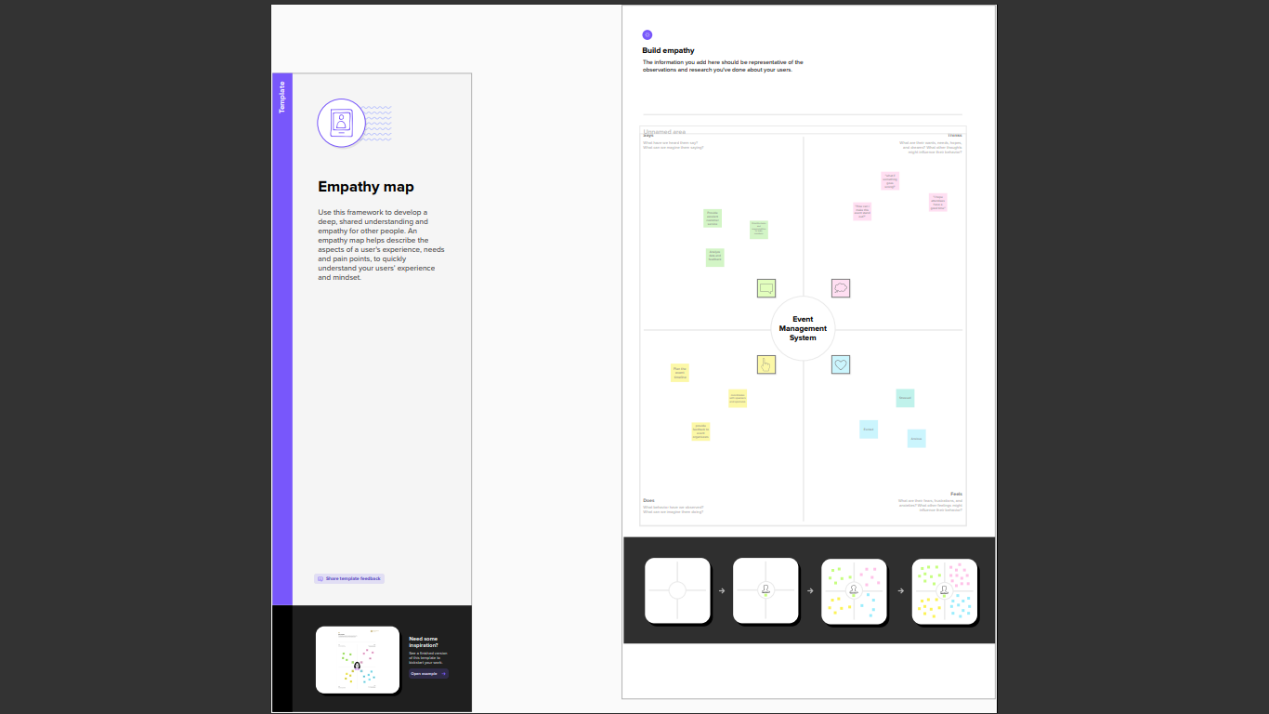

2.2 Ideation & Brainstorming Map

**3 Result**

3.1 Data Model

|  |  |
| --- | --- |
| **Object Name** | **Fields in the Object** |
| Obj 1 | |  |  | | --- | --- | | Field Label | Data Type | |  |  | |  |  | |
| Obj 2 | |  |  | | --- | --- | | Field Label | Data Type | |  |  | |  |  | |

3.2 Activity and Screenshot

**Trailhead Profile Public URL**

**Team Lead**  **-**[**https://trailblazer.me/id/priys87**](https://trailblazer.me/id/priys87)

**Team Member 1-**

**https://trailblazer.me/id/ppriyapriya2**

**Team Member 2 –**

**https://trailblazer.me/id/poovm2**

**Team Member 3 -**

**https://trailblazer.me/id/manip69**

**5**  **ADVANTAGES AND DISADVANTAGES**

Advantages ;

Event management system using Salesforce advantages

Salesforce is a powerful and flexible platform that can be used to build a variety of business applications, including event management systems. Here are some advantages of using Salesforce for event management:

Centralized data management: Salesforce allows you to manage all your event-related data in one central location, making it easy to access and update information on attendees, speakers, venues, sponsors, and more.

Customizable: Salesforce is highly customizable, allowing you to create event management workflows that align with your specific business requirements. You can customize fields, forms, and reports to fit your unique needs.

Integration: Salesforce integrates with a wide range of tools and applications, including marketing automation tools, social media platforms, and other third-party systems. This enables you to streamline your event management process and ensure a seamless experience for your attendees.

Automated tasks: Salesforce's automation capabilities allow you to automate tasks such as email notifications, registration confirmations, and post-event surveys. This saves time and ensures a consistent experience for attendees.

Real-time insights: Salesforce's reporting and analytics capabilities allow you to gain real-time insights into attendee engagement, event performance, and ROI. This information can be used to refine your event strategy and improve future events.

Mobile access: Salesforce can be accessed on-the-go via mobile devices, making it easy for event managers to stay connected and manage events from anywhere.

Overall, using Salesforce for event management can help you streamline your processes, improve attendee experience, and gain valuable insights into your event performance.

**Disadvantages ;**

Event management system using Salesforce disadvantages

While Salesforce offers many benefits as a platform for event management, there are also some potential disadvantages to consider:

Complexity: Salesforce is a powerful and complex platform, which means that it can be difficult and time-consuming to learn how to use it effectively. Setting up an event management system can require a significant amount of customization, which may require the assistance of a skilled Salesforce developer or consultant.

Cost: Salesforce is a premium platform, which means that it can be expensive to use. The cost of licensing, customization, and integration with other systems can add up quickly, especially for small or mid-sized organizations.

Integration: Salesforce is a standalone platform, which means that it may not integrate easily with other event management tools that your organization is already using. This can make it difficult to migrate data or maintain consistency across systems.

Limited functionality: While Salesforce offers many features for event management, it may not provide all of the functionality that your organization requires. Depending on your needs, you may need to develop custom solutions or integrate with third-party tools to meet your requirements.

Maintenance: Like any software system, Salesforce requires ongoing maintenance and updates to ensure that it remains secure and functional. This can require a significant investment of time and resources, especially if your organization has complex event management needs.

**6** **APPLICATONS**

An event management system application is software designed to help users manage and plan events. It typically includes features for tasks such as registration and ticketing, venue management, scheduling, marketing and promotion, and reporting.

Here are some key features that an event management system application might offer:

Registration and ticketing: The application should make it easy for attendees to register for the event and purchase tickets. It should also provide organizers with tools to manage the registration process, such as tracking attendee data and payments.

Venue management: The application should allow organizers to manage the venue for the event, including booking, layout planning, and managing equipment rentals.

Scheduling: The application should provide a scheduling tool for organizers to plan the event timeline, including sessions, breaks, and other activities.

Marketing and promotion: The application should provide tools for organizers to market and promote the event, such as email campaigns, social media integration, and promotional materials.

Reporting: The application should provide organizers with real-time data and analytics on the event, such as attendance numbers, ticket sales, and feedback from attendees.

Mobile app integration: An event management system application should have a mobile app integration so that attendees can access information about the event, view schedules, and receive updates in real-time.

Security and privacy: The application should ensure the security and privacy of attendee data, including protecting against fraud and unauthorized access

**7** **CONCLUSION**

An event management system is a software solution that can help event planners and organizers manage various aspects of an event, from ticketing and registration to scheduling and logistics. It can streamline event planning and execution, improve attendee experience, and provide valuable insights into event performance.

The use of an event management system can save time and reduce the chances of errors and miscommunications, as everything related to the event is stored in a centralized location accessible to all stakeholders. It can also automate many repetitive and time-consuming tasks, such as sending out confirmation emails and collecting feedback from attendees.

Moreover, an event management system can help event planners make data-driven decisions by providing real-time insights into attendee behavior and preferences, as well as event performance metrics. This can help event organizers improve the event experience, boost attendance, and increase revenue.

Overall, an event management system can provide significant benefits to event planners and organizers, including increased efficiency, improved attendee experience, and better decision-making capabilities. As such, it can be a valuable tool for anyone involved in planning and executing events, from small-scale gatherings to large-scale conferences and festivals.

**8** **FUTURE SCOPE**

The future scope of event management systems is vast and promising, with the advancement of technology and increasing demand for streamlined and efficient event planning and execution. Here are some potential areas of growth and development:

Integration with Virtual and Hybrid Events: With the rise of virtual and hybrid events due to the COVID-19 pandemic, event management systems will need to integrate with virtual event platforms and provide features such as live streaming, virtual networking, and attendee engagement tools.

Artificial Intelligence (AI) and Machine Learning (ML): Event management systems can leverage AI and ML algorithms to analyze data and predict attendee behavior, optimize event logistics, and personalize event experiences.

Augmented Reality (AR) and Virtual Reality (VR): AR and VR technologies can enhance the event experience by providing immersive and interactive elements such as 3D visualizations, gamification, and virtual product demos.

Internet of Things (IoT): IoT devices can be used to gather real-time data on attendee behavior and preferences, optimize event logistics, and monitor event performance.

Blockchain: Blockchain technology can be used to increase transparency and security in event transactions, such as ticket sales and sponsorships.

Sustainability: With increasing concerns about the environmental impact of events, event management systems can incorporate sustainability features such as carbon footprint tracking, waste reduction, and eco-friendly vendor sourcing.

Mobile Apps: Mobile event apps can provide attendees with personalized schedules, real-time updates, networking tools, and gamification features.

In summary, the future of event management systems will likely involve the integration of new technologies and a focus on personalization, interactivity, and sustainability to enhance the attendee experience and optimize event planning and execution.